Manual Test Plan for Project 1.2

Ziyang

CS 242

April 12, 2020

Software: Android Studio

Environment: React Native CLI

Setup Environment

* Follow <https://reactnative.dev/docs/environment-setup> to setup react native on your OS (OS X, Windows or Linux). It also tells you how to setup Android Studio for React Native after installing it.

Testing in Windows 10 with Android Emulator

1. Run the App

* Open cmd.exe and cd into your project root directory.
* Run "npx react-native run-android" to start. You should already have an android emulator or a real device when you setup environment.

Running this command should open a NodeJS command line prompt, a black blank command line window, and an Android emulator window.

(You may need to run "npx react-native run-android" again when some code is changed, so that react-native will run your app after installing app on the emulator.)

* Wait until everything finished.

1. Begin testing

* (For Project 1.2 Only), if you have set a app lock. You should see an verify screen when start the app. The screen looks like this:

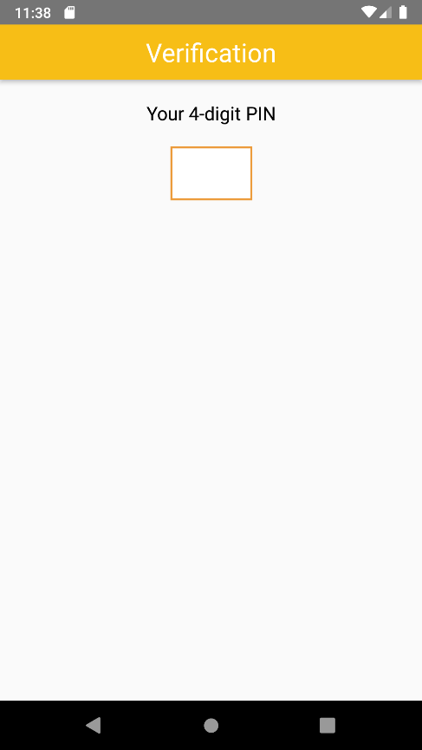

* If you give a wrong PIN, the input field should be cleared, and an error alert should jump out.
* If you give a correct PIN, you should enter the bottom-tab screen in the following paragraph. We'll talk about how to set a PIN later.
* Now you should see something similar to the following screen on your emulator.

Your screen may be a bit different if you are not using a Pixel 2 emulator.

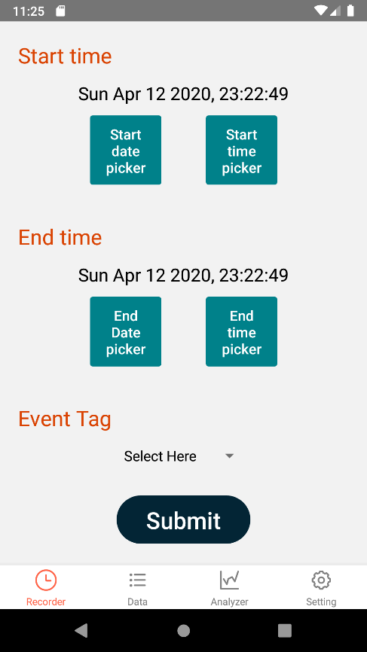

* To test navigation. simply click every icon on the bottom navigator.

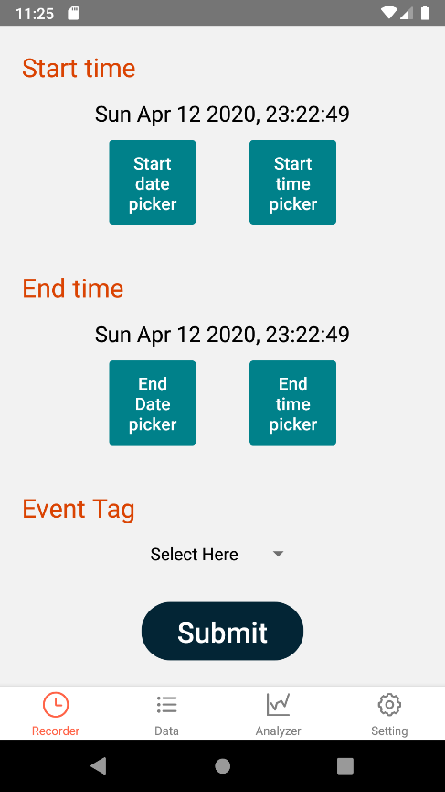

* For project-1.0 version, by clicking each icon you should see the following three screens for screens other than Recorder.
* Data Screen

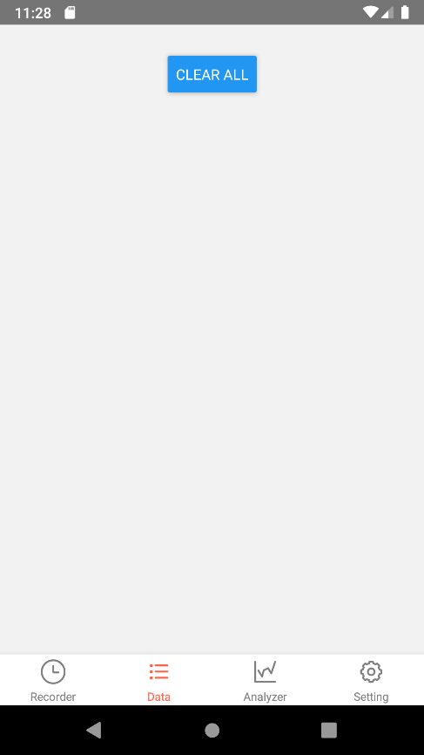

(For Project 1.1 Only) Now you should be able to see another button "REFRESH" next to "CLEAR ALL". By clicking the new button, you should be able to refresh the page and see changed data.

To test data screen, try to add some data in recorder. A correctly rendered data screen with some data should look like this.

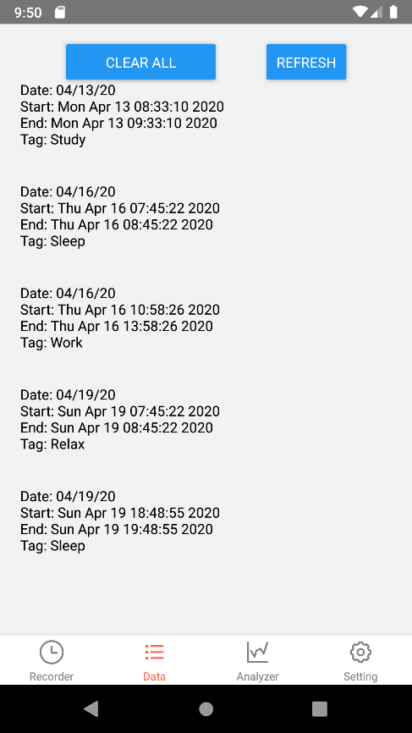

(For Project 1.2 Only) This should be the newly appearance of data screen in 1.2 with some data.

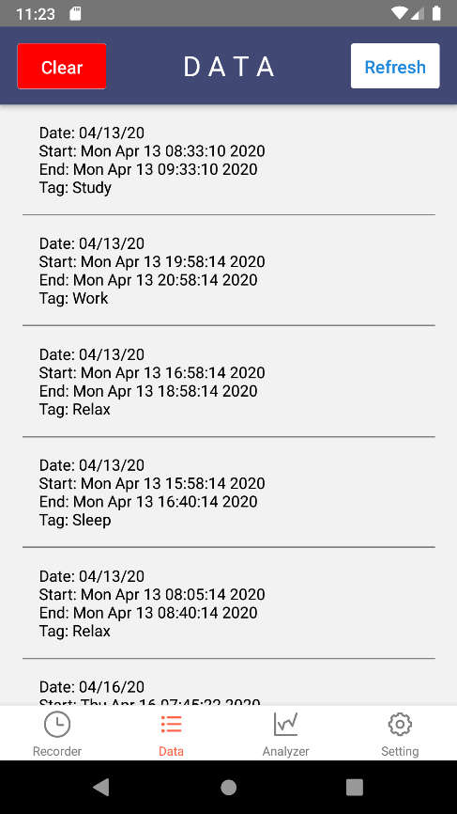

* Analyzer Screen

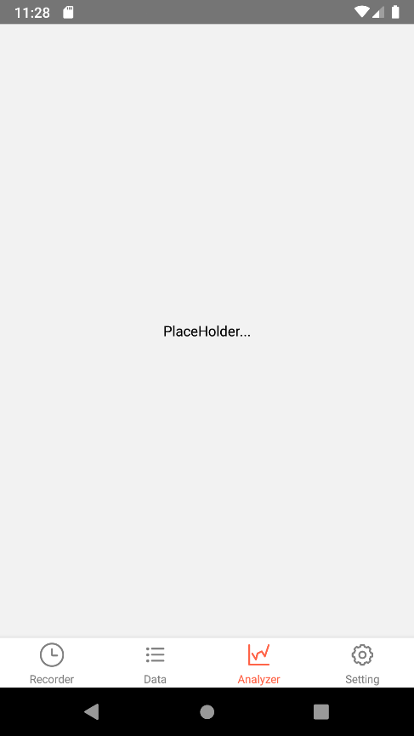

(For Project 1.1 Only) You should see this screen in default.

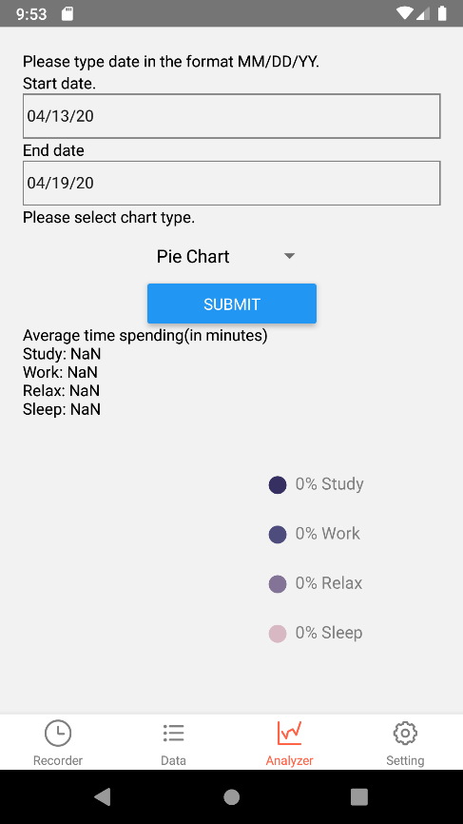

By clicking the "SUBMIT" button, you should see a screen like this. Your screen may looks a bit different since data are different.

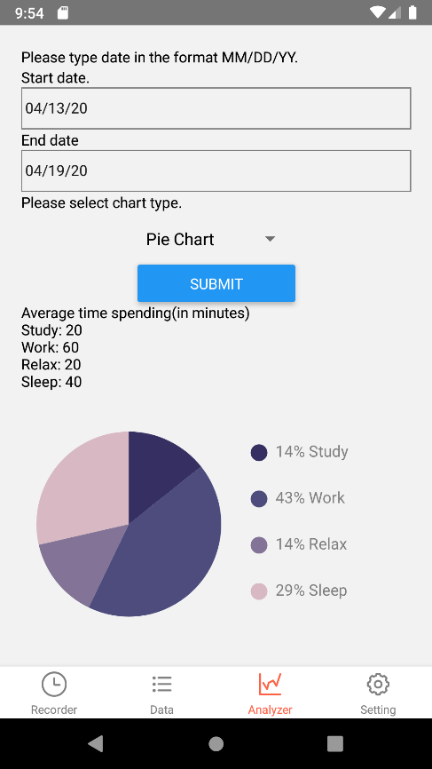

(For Project 1.2 Only) The appearance of the screen is updated, you now should see something like this.

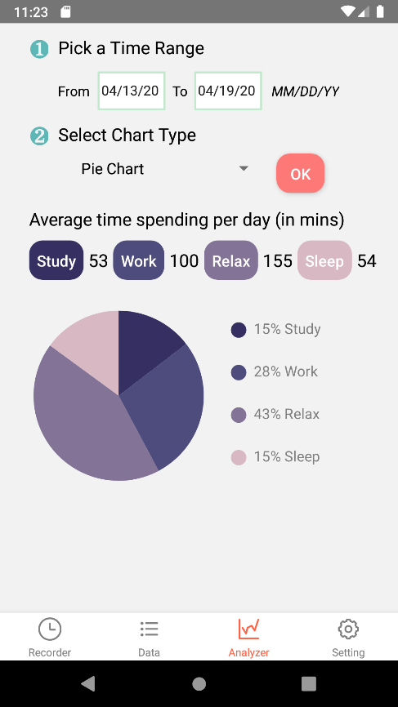

* Setting Screen

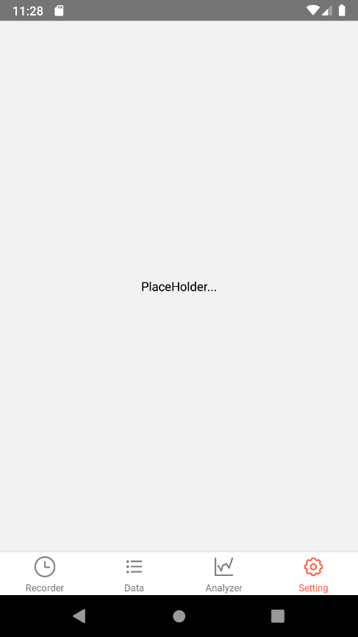

(For Project 1.2 Only) The placeholder now is replaced with a completed screen. By default, you should see the following screen.

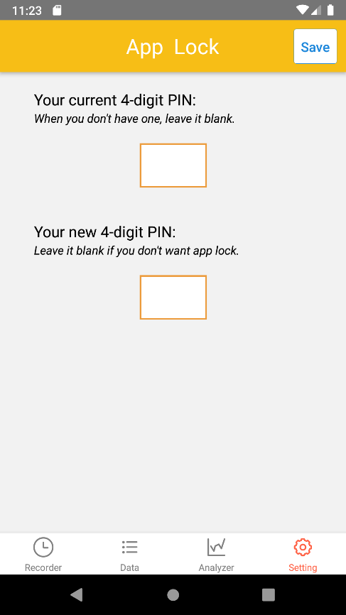

To test this screen:

1. For the first time, you can leave the first input area blank.

2. Type any 4-digit number (and remember it!) in the second input area.

3. Click "Save" on the right-top corner. You should see a success message.

4. Now you have a PIN already. Try to enter a wrong PIN in the first input area, and another PIN in the second, you should see an error message telling you that given PIN is not correct.

5. Try to type a 3-digit number in the second input area, you should also see an error message. (Because we need a 4-digit PIN)

6. With your PIN number, you can reload the app and try your PIN in the verify screen.

7. Test that when you set new PIN to empty, you don't see the verify screen when reloading the app.

* You should be able to click any times on the icons and view the correct screen without any errors.